**UNIT TESTING USING JES**

**Project Title: Project X**

**Prepared by: Team BAMP**

**Faculty of Computing, Engineering and Technology**

Test Cases Overview

1. Render Test - PASSED

```typescript

it('renders with correct label', () => {

const { getByText } = render(<Button label="Press Me" onPress={() => {}} />);

expect(getByText('Press Me')).toBeTruthy();

});

```

Purpose: Verifies that the button renders with the correct label text.

2. Event Handler Test - PASSED

```typescript

it('handles press events', () => {

const mockOnPress = jest.fn();

const { getByText } = render(<Button label="Press Me" onPress={mockOnPress} />);

fireEvent.press(getByText('Press Me'));

expect(mockOnPress).toHaveBeenCalledTimes(1);

});

```

Purpose: Ensures the button responds to user interactions correctly.

3. Style Test - (FAILED)

```typescript

it('applies custom styles when provided', () => {

const customStyle = { backgroundColor: 'red' };

const { getByTestId } = render(

<Button

label="Styled Button"

onPress={() => {}}

style={customStyle}

testID="custom-button"

/>

);

});

```

Error Found: `TypeError: expect(...).toHaveStyle is not a function`

Test Results Analysis

Test Suites: 1 failed, 1 passed, 2 total

Tests: 1 failed, 5 passed, 6 total

Snapshots: 1 passed, 1 total

Time: 8.067 s

Evidences:

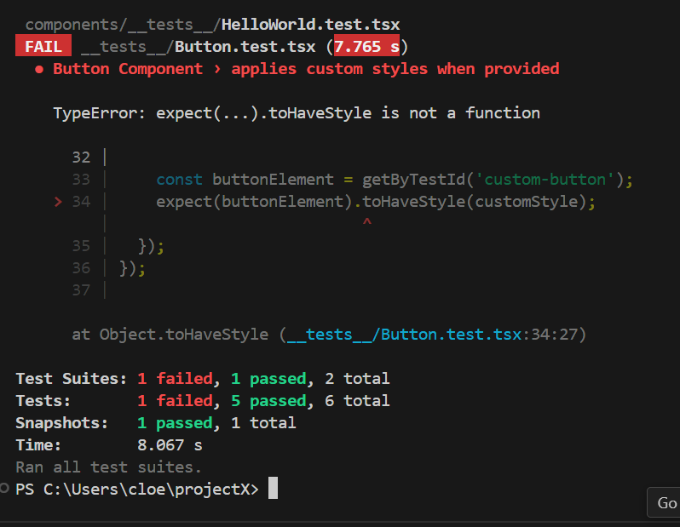

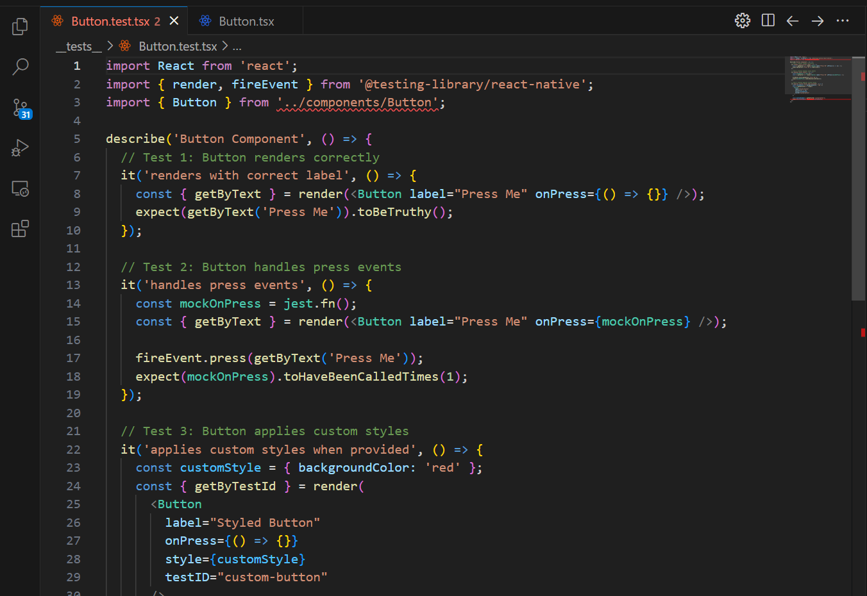

Testing Tools Used

1. Jest (Testing Framework)

2. React Native Testing Library

- `render()` for component rendering

- `fireEvent` for simulating user actions

- `getByText` and `getByTestId` for querying elements

Error Resolution Steps

To fix the failing style test:

1. Install @testing-library/jest-native

2. Update jest.config.js

3. Import style matchers in test file